Nama : Yudhitira Putra Hartanto
Kelas/absen : 1G/29
Prodi : D4 Teknik Informatika

Praktikum Pemilihan
- Input
package jobsheet1;
import java.util.Scanner;

public class PraktikumPemilihan {
static Scanner sc = new Scanner(System.in);
public static void main(String[] args) {
int nilaitugas, nilaikuis, nilaiuts, nilaiuas;
double nilaiakhir;

System.out.println("Program Menghitung Nilai Akhir");
System.out.println("====================================");

System.out.print("Masukkan Nilai Tugas: ");
nilaitugas = sc.nextInt();
System.out.print("Masukkan Nilai Kuis: ");
nilaikuis = sc.nextInt();
System.out.print("Masukkan Nilai UTS: ");
nilaiuts = sc.nextInt();
System.out.print("Masukkan Nilai UAS: ");
nilaiuas = sc.nextInt();

nilaiakhir = (0.2 * nilaitugas) + (0.2 * nilaikuis) + (0.3 * nilaiuts) + (0.3 * nilaiuas);

if(nilaiakhir > 100 || nilaitugas < 0 || nilaikuis < 0 || nilaiuts < 0 || nilaiuas < 0 || nilaitugas > 100 || nilaikuis > 100 || nilaiuts > 100 || nilaiuas > 100){
System.out.println("Input nilai tidak valid. Silakan masukkan nilai antara 0-100.");
System.out.println("====================================");
}

else if(nilaiakhir <= 100 || nilaitugas > 0 || nilaikuis > 0 || nilaiuts > 0 || nilaiuas > 0){
System.out.println("Nilai Akhir: " + nilaiakhir);
if (nilaiakhir > 80 && nilaiakhir <= 100) {
System.out.println("nilai huruf : A");
} else if (nilaiakhir > 73) {
System.out.println("nilai huruf : B+");
} else if (nilaiakhir > 65) {
System.out.println("nilai huruf : B");
} else if (nilaiakhir > 60) {
System.out.println("nilai huruf : C+");
} else if (nilaiakhir > 50) {
System.out.println("nilai huruf : C");
} else if (nilaiakhir > 39) {
System.out.println("nilai huruf : D");
} else {
System.out.println("nilai huruf : E");
}
if(nilaiakhir > 51){
System.out.println("Selamat Anda Lulus");
} else {
System.out.println("Selamat Anda Tidak Lulus");
}
System.out.println("====================================");
}
}
}

- Output
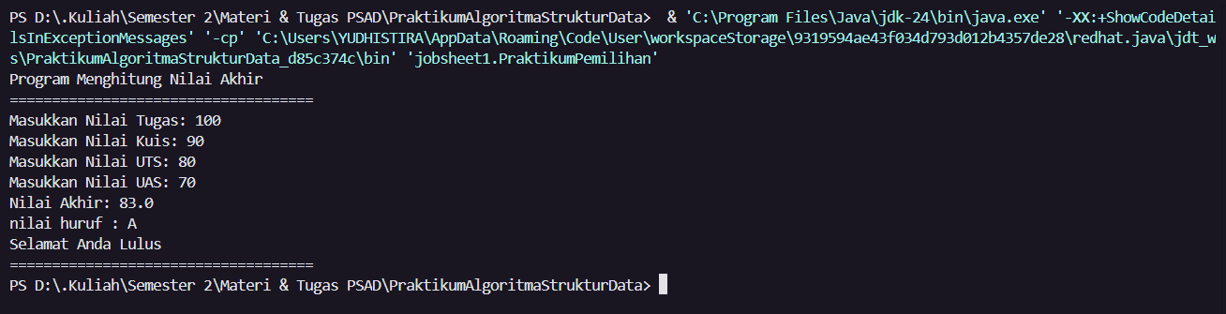

Praktikum Pengulangan
- Input
package jobsheet1;
import java.util.Scanner;

public class PraktikumPengulangan {
static Scanner sc = new Scanner (System.in);
public static void main(String[] args) {
double nim, nimakhir;

System.out.print("Masukkan NIM Anda: ");
nim = sc.nextDouble();

nimakhir = nim % 100;

if(nimakhir < 10){
nimakhir += 10;
System.out.println("NIM Akhir Anda adalah: " + nimakhir);
}else{
System.out.println("NIM Akhir Anda adalah: " + nimakhir);
}

for(int i = 1; i <= nimakhir; i++){
if (i == 10 || i == 15){
continue;
}else if(i % 2 == 1){
System.out.print("*" + " ");
}else if(i % 3 == 0){
System.out.print("#" + " ");
}else{
System.out.print(i + " ");
}

}
}
}

- Output
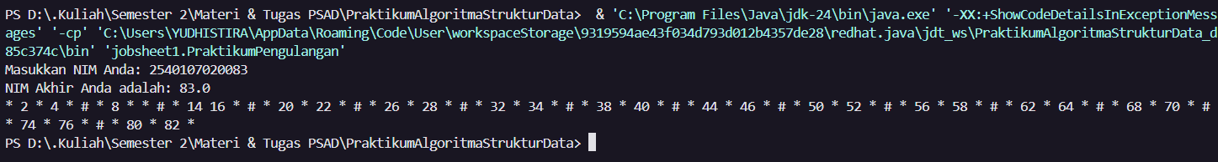

Praktikum Array
- Input
package jobsheet1;

import java.util.Scanner;

public class PraktikumArray {
static Scanner sc = new Scanner(System.in);
public static void main(String[] args) {
int nilai;
String[] mapel = new String [8];
int[] nilaiangka = new int [8];
String[] nilaihuruf = new String [8];
double[] bobot = new double [8];
int[] jmlsks = new int [8];

System.out.println("=======================================");
System.out.println("Program Menghitung IP Semester");
System.out.println("=======================================");

for(int i = 0; i < mapel.length; i++){
System.out.print("Masukkan nama mata pelajaran ke-" + (i + 1) + ": ");
mapel[i] = sc.nextLine();
System.out.print("Masukkan bobot sks : ");
jmlsks[i] = sc.nextInt();
sc.nextLine();

}
System.out.println("=======================================");

for(int i = 0; i < mapel.length; i++){
System.out.print("Masukkan nilai " + mapel[i] + ": ");
while(true){
nilai = sc.nextInt();
if(nilai < 0 || nilai > 100){
System.out.print("Nilai tidak valid. Masukkan nilai " + mapel[i] + " kembali: ");
} else {
break;
}
}
nilaiangka[i] = nilai;

if (nilai > 80 && nilai <= 110) {
nilaihuruf[i] = "A";
bobot[i] = 4.00;
} else if (nilai > 73) {
nilaihuruf[i] = "B+";
bobot[i] = 3.50;
} else if (nilai > 65) {
nilaihuruf[i] = "B";
bobot[i] = 3.00;
} else if (nilai > 60) {
nilaihuruf[i] = "C+";
bobot[i] = 2.50;
} else if (nilai > 50) {
nilaihuruf[i] = "C";
bobot[i] = 2.00;
} else if (nilai > 39) {
nilaihuruf[i] = "D";
bobot[i] = 1.00;
} else {
nilaihuruf[i] = "E";
bobot[i] = 0;
}
}

System.out.println("==============================");
System.out.println("\nhasil Konversi Nilai");
System.out.println("==============================");
System.out.println();
System.out.println("| MK | Nilai Angka | Nilai Huruf | Bobot Nilai |");
System.out.println("");

for(int i = 0; i < mapel.length; i++){
System.out.printf("| %-40s | %-10.2f | %-11s | %-11.2f |\n",
mapel[i], (double)nilaiangka[i], nilaihuruf[i], bobot[i]);
}

double totalbobot = 0;
int totalSks = 0;

for(int i = 0; i < mapel.length; i++){
totalbobot += bobot[i] * jmlsks[i];
totalSks += jmlsks[i];
}

double ipSemester = totalbobot / totalSks;

System.out.printf("\nIP : %.2f\n", ipSemester);

}

}

- Output
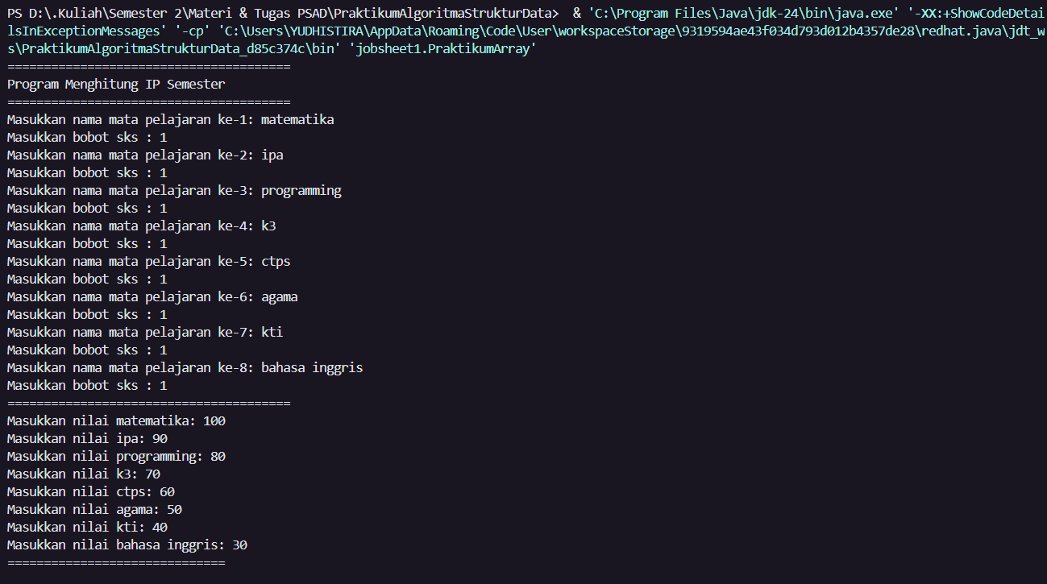
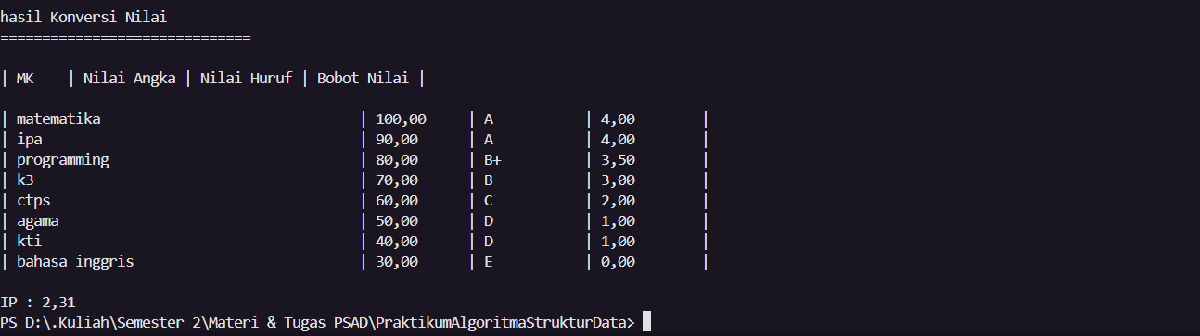

Praktikum Fungsi
- Input
package jobsheet1;

public class PraktikumFungsi {

static int[] hargaBunga = {75000, 50000, 60000, 10000};

public static void main(String[] args) {
int [][] royalgarden = {
{10, 5, 15, 7},
{6, 11, 9, 12},
{2, 10, 10, 5},
{5, 7, 12, 9}
};

System.out.println("=== PENDAPATAN SETIAP CABANG ===");
tampilkanPendapatan(royalgarden);

System.out.println("\n=== STATUS SETIAP CABANG ===");
tampilkanStatus(royalgarden);
}

static void tampilkanPendapatan(int[][] stock) {
for (int i = 0; i < stock.length; i++) {
int totalPendapatan = 0;

for (int j = 0; j < stock[i].length; j++) {
totalPendapatan += stock[i][j] * hargaBunga[j];
}

System.out.println("RoyalGarden " + (i + 1) + ": Rp" + totalPendapatan);
}
}

static void tampilkanStatus(int[][] stock) {
for (int i = 0; i < stock.length; i++) {
int totalPendapatan = 0;

for (int j = 0; j < stock[i].length; j++) {
totalPendapatan += stock[i][j] * hargaBunga[j];
}

String status;
if (totalPendapatan > 1500000) {
status = "Sangat Baik";
} else {
status = "Perlu Evaluasi";
}

System.out.println("RoyalGarden " + (i + 1) + ": Rp" + totalPendapatan + " - Status: " + status);
}
}
}

- Output
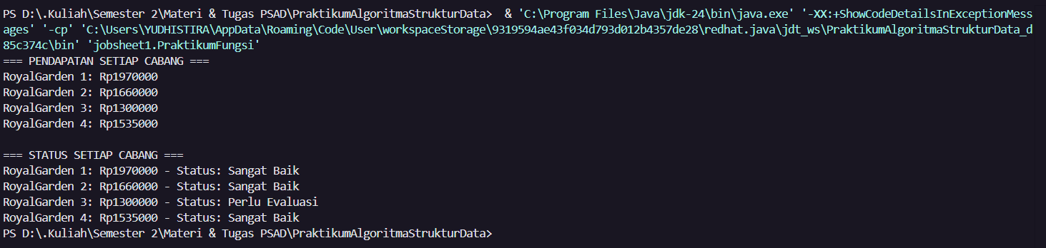

Tugas 1
- Input
package jobsheet1;
import java.util.Scanner;

public class Tugas1 {
static Scanner sc = new Scanner(System.in);
public static void main(String[] args) {
char[] KODE = {'A', 'B', 'D', 'E', 'F', 'G', 'H', 'L', 'N', 'T'};

char[][] KOTA = {
{'B', 'A', 'N', 'T', 'E', 'N'},
{'J', 'A', 'K', 'A', 'R', 'T', 'A'},
{'B', 'A', 'N', 'D', 'U', 'N', 'G'},
{'C', 'I', 'R', 'E', 'B', 'O', 'N'},
{'B', 'O', 'G', 'O', 'R'},
{'P', 'E', 'K', 'A', 'L', 'O', 'N', 'G', 'A', 'N'},
{'S', 'E', 'M', 'A', 'R', 'A', 'N', 'G'},
{'S', 'U', 'R', 'A', 'B', 'A', 'Y', 'A'},
{'M', 'A', 'L', 'A', 'N', 'G'},
{'T', 'E', 'G', 'A', 'L'}
};

System.out.println("\n");

System.out.print("Masukkan kode plat nomor (huruf kapital): ");
char kodeInput = sc.next().toUpperCase().charAt(0);

boolean ditemukan = false;
int index = -1;

for (int i = 0; i < KODE.length; i++) {
if (KODE[i] == kodeInput) {
index = i;
ditemukan = true;
break;
}
}

if (ditemukan) {
System.out.print("\nKode plat '" + kodeInput + "' adalah kota: ");

for (int j = 0; j < KOTA[index].length; j++) {
System.out.print(KOTA[index][j]);
}

System.out.println();
} else {
System.out.println("\nKode plat '" + kodeInput + "' tidak ditemukan.");
}

}

}

- Output
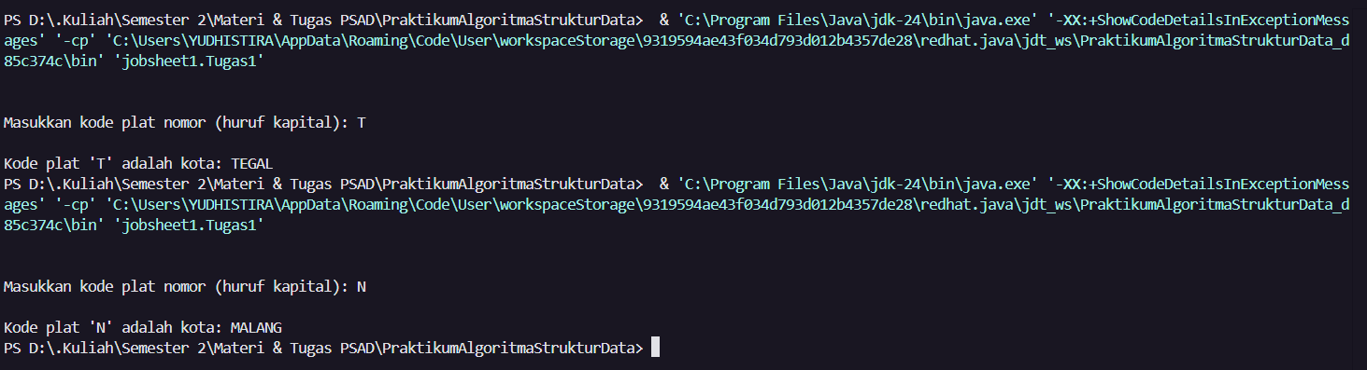

Tugas 2
- Input
package jobsheet1;

import java.util.Scanner;

public class Tugas2 {
static Scanner sc = new Scanner(System.in);

public static void main(String[] args) {
System.out.println("=== PROGRAM JADWAL KULIAH ===");

System.out.print("Masukkan jumlah jadwal kuliah: ");
int n = sc.nextInt();
sc.nextLine();

String[][] jadwal = new String[n][4];

int pilihan;
do {
System.out.println("\n=== MENU ===");
System.out.println("1. Input Jadwal Kuliah");
System.out.println("2. Tampilkan Semua Jadwal");
System.out.println("3. Cari Jadwal Berdasarkan Hari");
System.out.println("4. Cari Jadwal Berdasarkan Mata Kuliah");
System.out.println("5. Keluar");
System.out.print("Pilih menu (1-5): ");
pilihan = sc.nextInt();
sc.nextLine();

switch(pilihan) {
case 1:
inputJadwal(jadwal);
break;
case 2:
tampilkanSemuaJadwal(jadwal);
break;
case 3:
cariJadwalByHari(jadwal);
break;
case 4:
cariJadwalByMataKuliah(jadwal);
break;
case 5:
System.out.println("Terima kasih!");
break;
default:
System.out.println("Pilihan tidak valid!");
}
} while(pilihan != 5);
}

static void inputJadwal(String[][] jadwal) {
System.out.println("\n=== INPUT JADWAL KULIAH ===");

for(int i = 0; i < jadwal.length; i++) {
System.out.println("\nJadwal ke-" + (i+1) + ":");

System.out.print("Nama Mata Kuliah: ");
jadwal[i][0] = sc.nextLine();

System.out.print("Ruang: ");
jadwal[i][1] = sc.nextLine();

System.out.print("Hari Kuliah: ");
jadwal[i][2] = sc.nextLine();

System.out.print("Jam Kuliah (contoh: 08.00-10.00): ");
jadwal[i][3] = sc.nextLine();
}

System.out.println("\nData jadwal berhasil disimpan!");
}

static void tampilkanSemuaJadwal(String[][] jadwal) {
if(jadwal[0][0] == null) {
System.out.println("\nBelum ada data jadwal!");
return;
}

System.out.println("\n=== DAFTAR JADWAL KULIAH ===");
System.out.println("=================================================================================");
System.out.println("| No | Mata Kuliah | Ruang | Hari | Jam |");
System.out.println("=================================================================================");

for(int i = 0; i < jadwal.length; i++) {
if(jadwal[i][0] != null) {
System.out.printf("| %-3d| %-20s | %-20s | %-7s | %-15s |\n",
(i+1), jadwal[i][0], jadwal[i][1], jadwal[i][2], jadwal[i][3]);
}
}

System.out.println("=================================================================================");
}

static void cariJadwalByHari(String[][] jadwal) {
if(jadwal[0][0] == null) {
System.out.println("\nBelum ada data jadwal!");
return;
}

System.out.print("\nMasukkan hari yang dicari: ");
String hariCari = sc.nextLine();

System.out.println("\n=== JADWAL PADA HARI " + hariCari.toUpperCase() + " ===");
System.out.println("=================================================================================");
System.out.println("| No | Mata Kuliah | Ruang | Hari | Jam |");
System.out.println("=================================================================================");

boolean ditemukan = false;
for(int i = 0; i < jadwal.length; i++) {
if(jadwal[i][0] != null && jadwal[i][2].equalsIgnoreCase(hariCari)) {
System.out.printf("| %-3d| %-20s | %-20s | %-7s | %-15s |\n",
(i+1), jadwal[i][0], jadwal[i][1], jadwal[i][2], jadwal[i][3]);
ditemukan = true;
}
}

if(!ditemukan) {
System.out.println("| TIDAK ADA JADWAL PADA HARI INI |");
}

System.out.println("=================================================================================");
}

static void cariJadwalByMataKuliah(String[][] jadwal) {
if(jadwal[0][0] == null) {
System.out.println("\nBelum ada data jadwal!");
return;
}

System.out.print("\nMasukkan nama mata kuliah yang dicari: ");
String mkCari = sc.nextLine();

System.out.println("\n=== JADWAL MATA KULIAH: " + mkCari.toUpperCase() + " ===");
System.out.println("=================================================================================");
System.out.println("| No | Mata Kuliah | Ruang | Hari | Jam |");
System.out.println("=================================================================================");

boolean ditemukan = false;
for(int i = 0; i < jadwal.length; i++) {
if(jadwal[i][0] != null && jadwal[i][0].equalsIgnoreCase(mkCari)) {
System.out.printf("| %-3d| %-20s | %-20s | %-7s | %-15s |\n",
(i+1), jadwal[i][0], jadwal[i][1], jadwal[i][2], jadwal[i][3]);
ditemukan = true;
}
}

if(!ditemukan) {
System.out.println("| MATA KULIAH TIDAK DITEMUKAN DALAM JADWAL |");
}

System.out.println("=================================================================================");
}
}

- Output
